**Zhumagali Kanat IT2-2003**

**Lab5. Creating Functions and Packages**

1. Create at least 3 functions for your database. You may use the anonymous blocks you created in Lab 2 as a basis.
2. At least 2 functions must be with parameters.
3. Combine your procedures (Lab 4) and functions (Lab 5) into at least 2 packages. Procedures and functions of one package must be logically related.
4. During the defense you must demonstrate the execution of procedures and functions.

create or replace function get_movies return varchar2(4000)

is

movie_info VARCHAR2(4000);

begin

for sal_record in (select movie_id, film_name, duration, year_of_release from movie where YEAR_OF_RELEASE > 2000 order by year_of_release ASC) LOOP

movie_info := movie_info || 'Movie id : ' || sal_record.movie_id || ' Film name : ' || sal_record.film_name || ' Duration: ' || sal_record.duration || ' Year of release: ' || sal_record.year_of_release || CHR(10);

end loop;

return movie_info;

end;

declare

movie_list VARCHAR2(4000);

begin

movie_list := get_movies();

dbms_output.put_line(movie_list);

end;

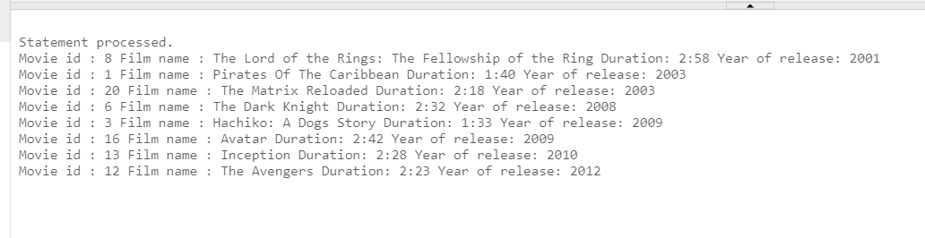

create or replace function get_movie_info (

m_id movie.movie_id%TYPE

)

return varchar2

is

m_name movie.film_name%TYPE;

m_duration movie.duration%TYPE;

m_year movie.year_of_release%TYPE;

movie_info VARCHAR2(4000); -- Adjust the size based on your actual requirements

begin

select film_name, duration, year_of_release into m_name, m_duration, m_year from movie where movie_id = m_id;

movie_info := 'Movie name: ' || m_name || ' duration: ' || m_duration || ' year of release: ' || m_year;

return movie_info;

end get_movie_info;

declare

m_info VARCHAR2(4000);

begin

m_info := get_movie_info(4);

dbms_output.put_line(m_info);

end;

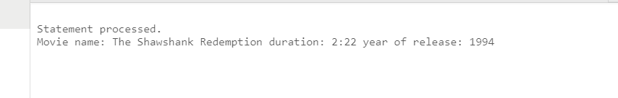

create or replace function get_genre_movies(my_genre genre.genre_name%TYPE)

return varchar2

is

genre_info VARCHAR2(4000);

begin

for genre_rec in (select genre_id, genre_name from genre where genre_name = my_genre) loop

genre_info := genre_info || genre_rec.genre_id || ' Genre name: ' || genre_rec.genre_name || CHR(10);

for movie_genre_info_rec in (select m.movie_id, m.film_name, m.year_of_release from movie m join movie_genre mg ON mg.movie_id = m.movie_id where mg.genre_id = genre_rec.genre_id) loop

genre_info := genre_info ||

'Movie id: ' || movie_genre_info_rec.movie_id ||

' Film name: ' || movie_genre_info_rec.film_name ||

' Year of release: ' || movie_genre_info_rec.year_of_release || CHR(10);

end loop;

end loop;

return genre_info;

end get_genre_movies;

declare

genre_info_result VARCHAR2(4000);

begin

genre_info_result := get_genre_movies('Adventure');

dbms_output.put_line(genre_info_result);

end;

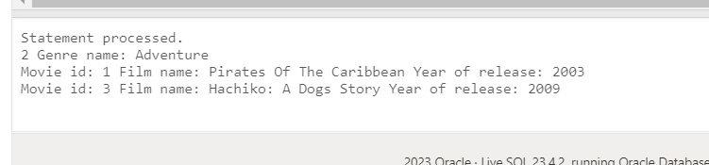

create or replace package mov_pkg is

procedure print_movies;

function get_movies return varchar2;

end mov_pkg;

create or replace package body mov_pkg is

procedure print_movies is

begin

for sal_record in (select movie_id, film_name, duration, year_of_release from movie where YEAR_OF_RELEASE > 2000 order by year_of_release asc) loop

dbms_output.put_line('Movie id : ' || sal_record.movie_id || ' Film name : ' || sal_record.film_name || ' Duration: ' || sal_record.duration || ' Year of release: ' || sal_record.year_of_release);

end loop;

end;

function get_movies return varchar2

is

movie_info VARCHAR2(4000);

begin

for sal_record in (select movie_id, film_name, duration, year_of_release from movie where YEAR_OF_RELEASE > 2000 order by year_of_release ASC) LOOP

movie_info := movie_info || 'Movie id : ' || sal_record.movie_id || ' Film name : ' || sal_record.film_name || ' Duration: ' || sal_record.duration || ' Year of release: ' || sal_record.year_of_release || CHR(10);

end loop;

return movie_info;

end;

end mov_pkg;

execute mov_pkg.print_movies

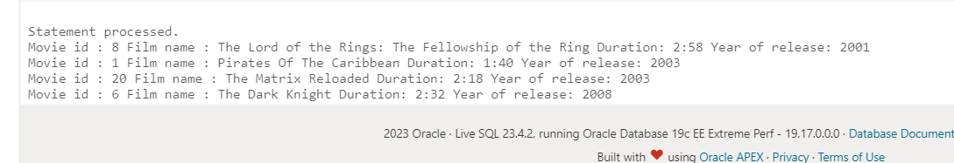

create or replace package genre_pkg is

procedure fetch_genre_movies (my_genre genre.genre_name%type );

function get_genre_movies(my_genre genre.genre_name%TYPE) return varchar2;

end genre_pkg;

create or replace package body genre_pkg is

procedure fetch_genre_movies (my_genre in genre.genre_name%type ) IS

cursor genre_cursor is select genre_id, genre_name from genre where genre_name = my_genre;

cursor movie_g_info(g_id NUMBER) IS

select m.movie_id, m.film_name, m.year_of_release from movie m join movie_genre mg on mg.movie_id = m.movie_id where mg.genre_id = g_id;

genre_rec genre_cursor%ROWTYPE;

movie_genre_info_rec movie_g_info%ROWTYPE;

begin

for genre_rec in genre_cursor loop

DBMS_OUTPUT.PUT_LINE(genre_rec.genre_id || ' Genre name: ' || genre_rec.genre_name);

for movie_genre_info_rec IN movie_g_info(genre_rec.genre_id) LOOP

DBMS_OUTPUT.PUT_LINE(

'Movie id: ' || movie_genre_info_rec.movie_id ||

' Film name: ' || movie_genre_info_rec.film_name ||

' Year of release: ' || movie_genre_info_rec.year_of_release

);

end loop;

end loop;

end fetch_genre_movies;

function get_genre_movies(my_genre genre.genre_name%TYPE)

return varchar2

is

genre_info VARCHAR2(4000);

begin

for genre_rec in (select genre_id, genre_name from genre where genre_name = my_genre) loop

genre_info := genre_info || genre_rec.genre_id || ' Genre name: ' || genre_rec.genre_name || CHR(10);

for movie_genre_info_rec in (select m.movie_id, m.film_name, m.year_of_release from movie m join movie_genre mg ON mg.movie_id = m.movie_id where mg.genre_id = genre_rec.genre_id) loop

genre_info := genre_info ||

'Movie id: ' || movie_genre_info_rec.movie_id ||

' Film name: ' || movie_genre_info_rec.film_name ||

' Year of release: ' || movie_genre_info_rec.year_of_release || CHR(10);

end loop;

end loop;

return genre_info;

end get_genre_movies;

end genre_pkg;

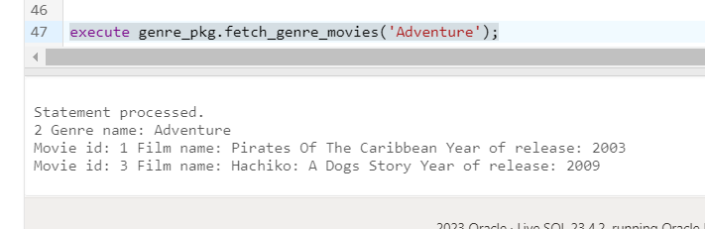

Questions:

1. Define a function in PL/SQL.
2. Different ways of invoking functions.
3. Packages and their structure.
4. The purpose of creating packages.
5. Private and public components of the package.
6. What is package specification?
7. What is a package body?
8. What is the difference between a procedure declared in the package specification and a procedure declared only in the package body?
9. Explain the notion of the forward declaration.
10. In which cases the forward declaration must be used?
11. What is overloading? And what are its limitations?
12. What is the package state?
13. How is a package created?
14. Is it allowed to initialize variables in the package specification?
15. How are methods invoked inside the package where it is declared?
16. How are methods invoked outside of the package where it is declared?
17. Define the notion of bodiless packages.
18. Describe the BEGIN section in a package.